Introduction

These experiments should be used as follows: The student should follow the procedures outlined in each experiment and collect data or write notes based on their observations. The instructor reviews each students notes and/or data immediately after the procedure is completed and makes comments and recommendations.

At the end of the lab the data/notes sheet(s) are finalized and the instructor signs the sheet(s) Based on the data/notes collected the student prepares a report due at the next lab and hands it to the instructor along with the signed data/notes sheet(s). The students should use in their reports the actual data collected.

If data are far from expected results the student should attempt to analyze and explain the source of the errors.

**Instrumentation and measurements for digital circuits**

**Objectives:**

1. To Become familiar with understanding TTL data sheet
2. To learn how to use the breadboard space efficiently
3. To become familiar with voltage and current measurement in digital circuits
4. To learn to use the oscilloscope for troubleshooting digital circuits
5. To learn to use the function generator as a source of digital signals

**Understanding IC Package Data Sheet**

* VIH(min): High Level Input Voltage : minimum voltage level required for logic 1 at an input
* VIL(max): Low Level Input Voltage : maximum voltage level required for logic 0 at an input
* VoH(min): High Level Output Voltage : minimum voltage level at an output for logic 1 state
* VOL(max): Low Level Output Voltage : maximum voltage level at an output for logic 1 state
* IIH: High Level Input Current : Current flowing into an input at a logic state 1
* IIL: Low Level Input Current : Current flowing into an input at a logic state 0
* IOH: High Level Output Current : Current flowing from an output at logic state 1
* IOL: Low Level Output Current : Current flowing from an output at logic state 0
* Fan out: Maximum number of logic inputs that an output can drive reliably
* Delay encountered by a signal in going through a circuit
  + tPLH delay time in going from logic 0 to logic 1
  + tPHL delay time in going from logic 1 to logic 0

**TTL Data Sheets**

* First line of TTL ICs was the 54/74 series
  + 54 series operates over a wider temperature range
* Same numbering system, prefix indicates manufacturer
  + SN – Texas Instruments
  + DM – National Semiconductor
  + S – Signetics
  + DM7402, SN7402, S7402 all perform the same function
* Data sheets contain electrical characteristics, switching characteristics, and recommended operating conditions.

**TTL Series Characteristics**

* Standard 74 series TTL has evolved into other series:
  + Standard TTL, 74 series
  + Schottky TTL, 74S series
  + Low power Schottky TTL, 74LS series (LS-TTL)
  + Advanced Schottky TTL, 74AS series (AS-TTL)
  + Advanced low power Schottky TTL, 74ALS series
  + 74F fast TTL

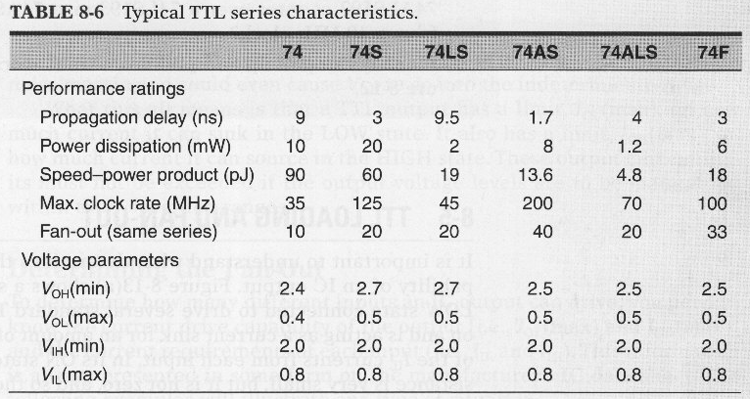

**Example of data sheet**

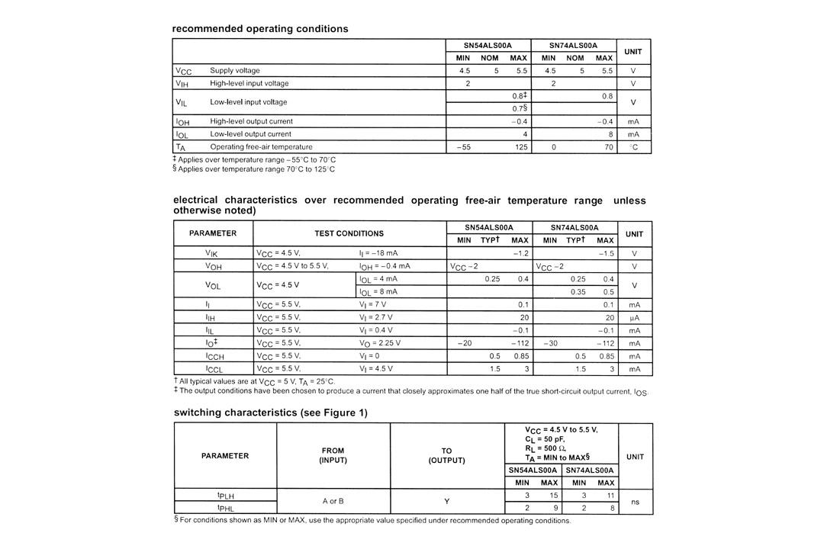

**Pin configuration:**

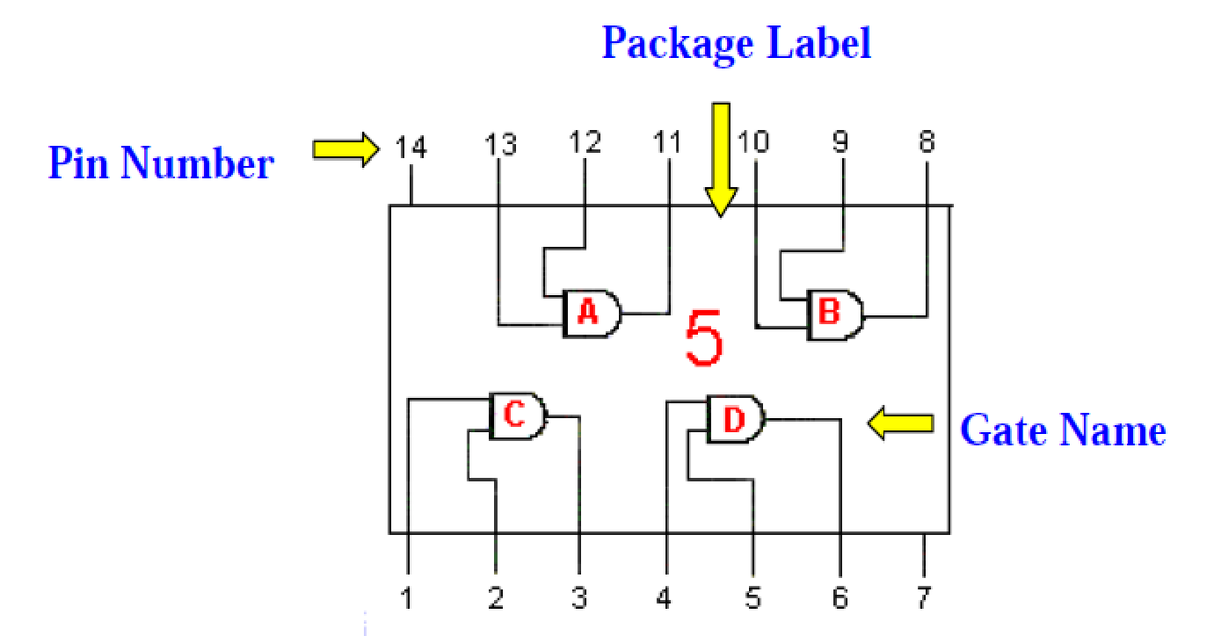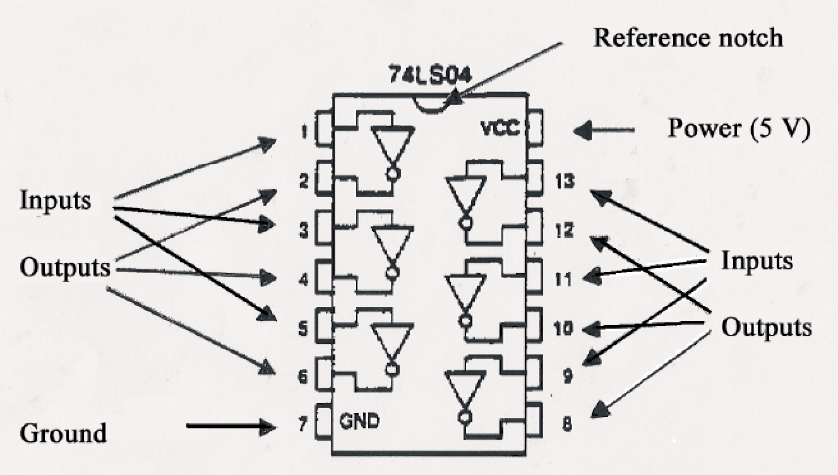



**Breadboard Description.**

In order to assemble the lab experiments, every student should use his/her own breadboard (similar to the one shown in Figure 6). The breadboard has 8 sets of rows (1) and (2), consisting of 25 holes that are horizontally interconnected, and groups of columns (3) and (4), consisting of 5 holes that are vertically interconnected. The rows and columns are used to hold chips and wires, and interconnect them as shown in Figures, in those Figures show two typical ways to distribute power (1), and ground (2) signals that are recommended in order to avoid noise in your circuit, and assure good performance from the chips. The banana plugs (3), if available, can be used to connect your breadboard to an external power supply (usually the Heathkit board).

The 5V supply **MUST NOT BE EXCEEDED** since this will damage the ICs (Integrated circuits) used during the experiments. Incorrect connection of power to the ICs could result in them exploding or becoming very hot - with the **possible serious injury occurring to the people working on the experiment! Ensure that the power supply polarity and all components and connections are correct before switching on power .**

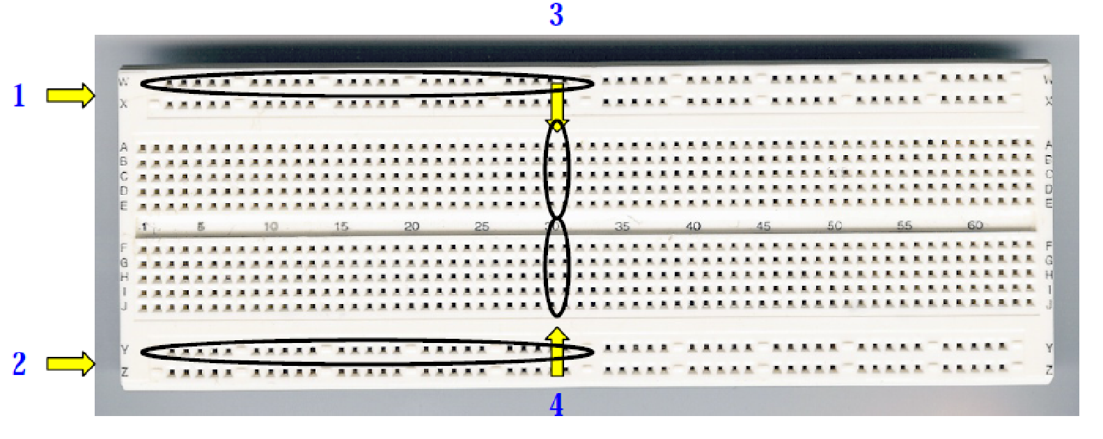

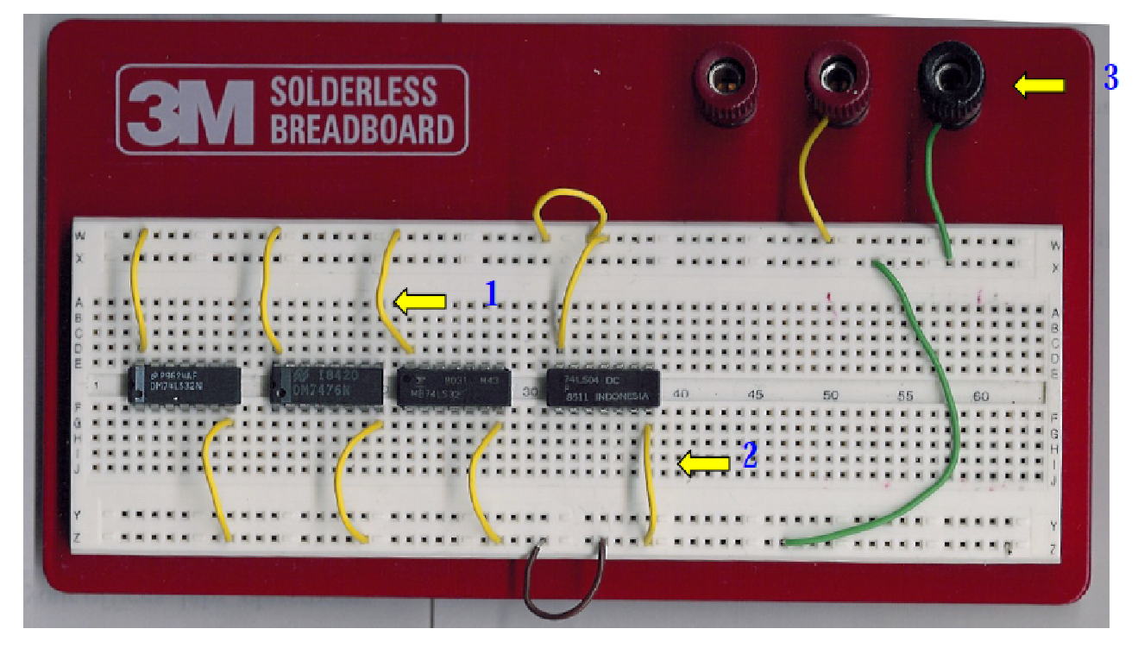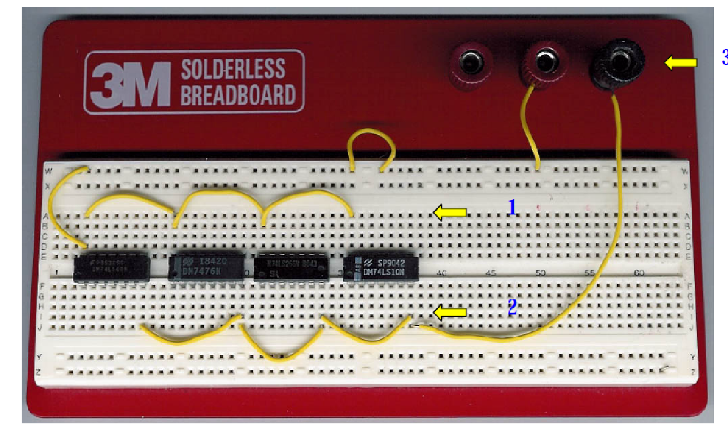

**The voltage and current measurement in digital circuits:**

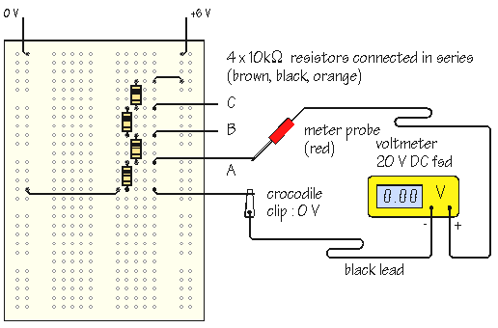

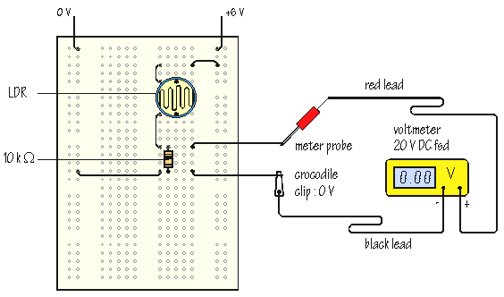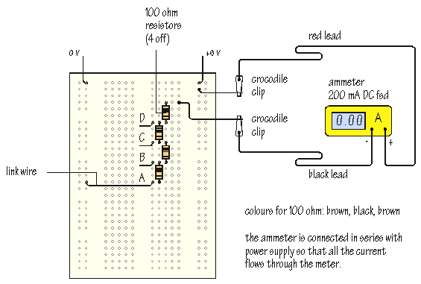

**Common Causes of Problems**

|  |
| --- |
| * Not connecting the ground and/or power pins for all chips. |
| * Not turning on the power supply before checking the operation of the circuit. |
| * Leaving out wires. |
| * Plugging wires into the wrong holes. |
| * Driving a single gate input with the outputs of two or more gates |
| * Modifying the circuit with the power on. |

**List of Experiments**

|  |  |  |
| --- | --- | --- |
| **Exp No.** | **Name of the Experiment** | **Weight** |
| 1. | Simple Experiments: Uses of components and measuring devices | Fundamental |
| 2. | Study of Logic Gates | Simple |
| 3. | Design and Implement simple combinational Logic circuits | Moderate |
| 4. | Study the the switching property of TTL and DTL logic gates | Moderate |
| 5. | Design and Implement of SR and JK flip-flop , T | Moderate |
| 6. | Design and Implement of Astable multivibrator using 555 timer | Moderate |
| 7. | Design and Implement of Monostatble multivibrator using 555 timer | Moderate |

**Evaluation Process:**

|  |  |  |  |
| --- | --- | --- | --- |
| **S/N** | **Evaluation Criteria** | **Mode** | **Marks (%)** |
| 1 | Understanding of the given problem | Viva/voce | 10 |
| 2 | Truth Table and Design | Observation | 30 |
| 3 | Circuit Connection | Observation | 30 |
| 4 | Functionalities of the circuits | Observation and Viva/voce | 20 |
| 5 | Operation explanation | Viva/voce | 10 |

**Laboratory notes:**

1. Student have to keep separate laboratory note book for this lab
2. They have to keep successful design of the circuit of the day and in the following day, get respective teacher’s signature of their notebooks
3. They have note down the explanation any error/mistake(s) found during the circuit connection and also note down the precaution (if any).

**Experiment # 1:**

**Simple Experiments: Uses of components and measuring devices**

**Objectives**

* To learn to use the oscilloscope for troubleshooting digital circuits
* To learn to use the function generator as a source of digital signals

**Equipment:**

* Oscilloscope
* Function generator with analog and digital outputs
* Breadboard and wires
* 7404 or 74LS04 (1), LED's (1)
* Resistors : 150Ω(1), 1KΩ(1), 4.7KΩ(1), 470KΩ(1)
* Transistors : 2N2222/ C828/ BC109 or any general purpose NPN (1)

**Preparation**

1. Identify the function generator. Identify the analog and digital outputs.

2. Connect the oscilloscope to the analog output of the function generator. Set the oscilloscope to DC mode. Vary the frequency, output voltage and offset adjustment of the function generator and observe the waveform on the oscilloscope.

3. Connect the oscilloscope to the digital output of the function generator. Set the oscilloscope to DC mode. Vary the frequency, output voltage and offset adjustment of the function generator and observe the waveform on the oscilloscope.

**Experiment # 1(a):**

1. Build the circuit shown below.

2. Change the frequency and the output voltage of the function generator and observe the output of the circuit to the oscilloscope. Comment on the function performed by the circuit. Consult your instructor.

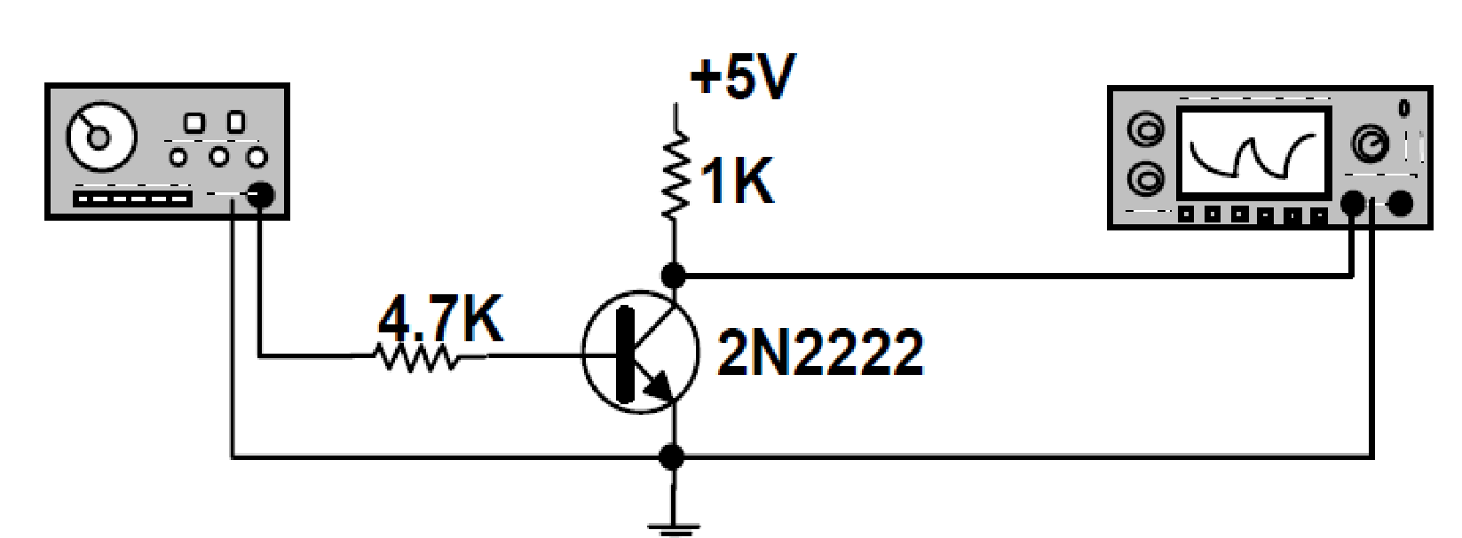

**Experiment # 1(b):**

Construct the circuits shown on the next diagram and analyze their operation. Correlate the signal applied to their input( 0 or 1) to the status of the LED (ON or OFF). The circuit labeled "C" lists two types of gates 7404 or 7406. Even though both gates will perform the intended task the 7406 (open collector) is the choice for this kind of arrangement.

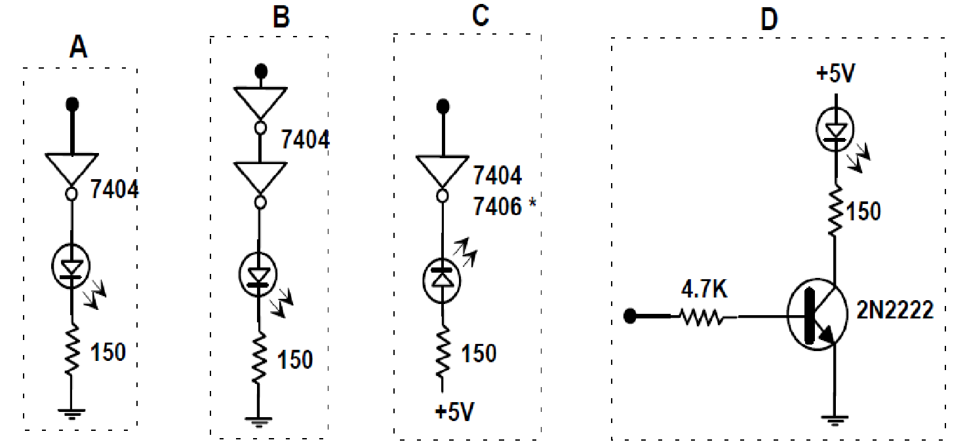

# Experiment # 2: : STUDY OF LOGIC GATES

**DATE :**

**Objective:**

To study about logic gates and verify their truth tables.

**APPARATUS REQUIRED:**

|  |  |  |  |
| --- | --- | --- | --- |
| SL No. | COMPONENT | SPECIFICATION | QTY |
| 1. | AND GATE | IC 7408 | 1 |
| 2. | OR GATE | IC 7432 | 1 |
| 3. | NOT GATE | IC 7404 | 1 |
| 4. | NAND GATE 2 I/P | IC 7400 | 1 |
| 5. | NOR GATE | IC 7402 | 1 |
| 6. | X-OR GATE | IC 7486 | 1 |
| 7. | NAND GATE 3 I/P | IC 7410 | 1 |
| 8. | IC TRAINER KIT | - | 1 |
| 9. | PATCH CORD | - | 14 |

**THEORY:**

Circuit that takes the logical decision and the process are called logic gates. Each gate has one or more input and only one output.

OR, AND and NOT are basic gates. NAND, NOR and X-OR are known as universal gates. Basic gates form these gates.

**AND GATE:**

The AND gate performs a logical multiplication commonly known as AND function. The output is high when both the inputs are high. The output is low level when any one of the inputs is low.

## **OR GATE:**

## The OR gate performs a logical addition commonly known as OR function. The output is high when any one of the inputs is high. The output is low level when both the inputs are low.

**NOT GATE:**

The NOT gate is called an inverter. The output is high when the input is low. The output is low when the input is high.

**NAND GATE:**

The NAND gate is a contraction of AND-NOT. The output is high when both inputs are low and any one of the input is low .The output is low level when both inputs are high.

**NOR GATE:**

The NOR gate is a contraction of OR-NOT. The output is high when both inputs are low. The output is low when one or both inputs are high.

**X-OR GATE:**

The output is high when any one of the inputs is high. The output is low when both the inputs are low and both the inputs are high.

**PROCEDURE:**

1. Connections are given as per circuit diagram.
2. Logical inputs are given as per circuit diagram.
3. Observe the output and verify the truth table.

**AND GATE:**

**SYMBOL: PIN DIAGRAM:**

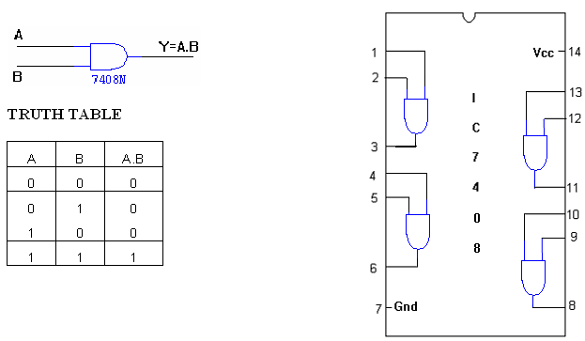

**OR GATE:**

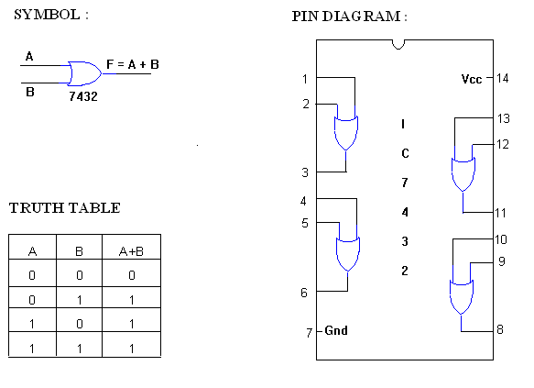

**NOT GATE:**

**SYMBOL: PIN DIAGRAM:**

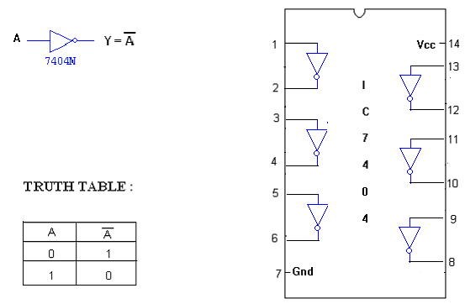

**X-OR GATE :**

**SYMBOL : PIN DIAGRAM :**

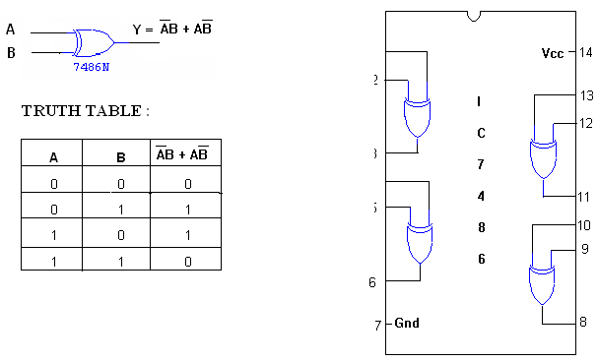

**2-INPUT NAND GATE:**

**SYMBOL: PIN DIAGRAM:**

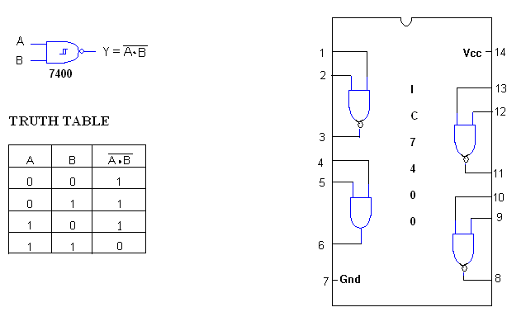

**3-INPUT NAND GATE :**

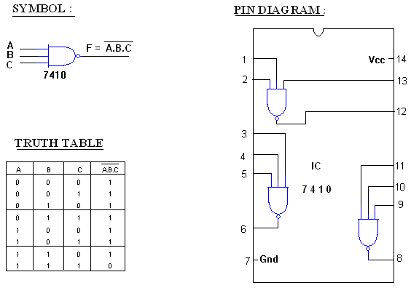

**NOR GATE:**

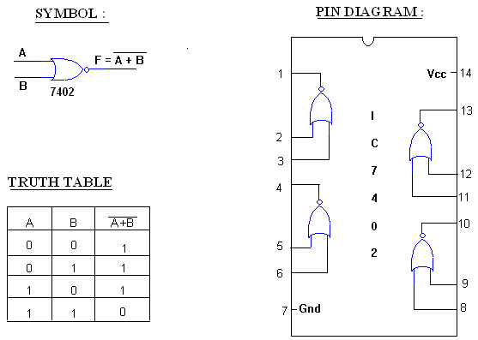

**Experiment # 3:**

**Design and Implement simple combinational Logic circuits**

**Problem Statements:**

A warning buzzer is to sound when the following conditions apply:

|  |  |
| --- | --- |
|  | * Switches A, B, C are on. |
|  | * Switches A and B are on but switch C is off. |
|  | * Switches A and C are on but switch B is off. |
|  | * Switches C and B are on but switch A is off. |

Draw a truth table for this situation and obtain a Boolean expression for it. Minimize this expression and draw a logic diagram using only a) NAND b) NOR gates. If the delay of a NAND gate is 15ns and that of a NOR gate is 12ns, which implementation is faster.

**Equipment:**

* Oscilloscope
* Function generator with analog and digital outputs
* Breadboard and wires
* 7404 or 74LS04 (1), LED's (1)
* Resistors : 150Ω(1), 1KΩ(1), 4.7KΩ(1), 470KΩ(1)
* Transistors : 2N2222/ C828/ BC109 or any general purpose NPN (1)

**Experiment # 4:**

**Study the switching property of TTL and DTL logic gates**

**Objectives**

* To learn to use the oscilloscope for troubleshooting digital circuits
* To learn to use the function generator as a source of digital signals

**Equipment:**

* Oscilloscope
* Function generator with analog and digital outputs
* Breadboard and wires
* Transistor C828, /BC 107/BC108/BC109
* Resistors : 4.7KΩ(1), 470KΩ(1)

**Experiment # 5:**

**Design and Implement of SR and JK flip-flop**

**Objectives**

* To learn to use the oscilloscope for troubleshooting digital circuits
* To learn to use the function generator as a source of digital signals

**Equipment:**

* Oscilloscope
* Function generator with analog and digital outputs
* Breadboard and wires
* 7404 or 74LS04 (1), LED's (1)
* Resistors : 150Ω(1), 1KΩ(1), 4.7KΩ(1), 470KΩ(1)
* Transistors : 2N2222/ C828/ BC109 or any general purpose NPN (1)

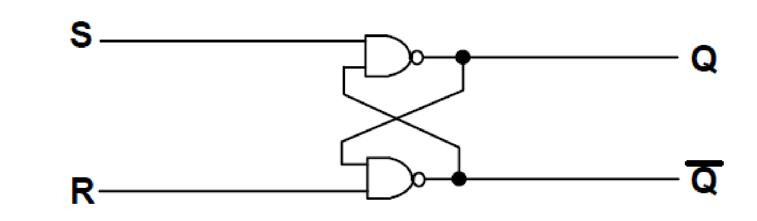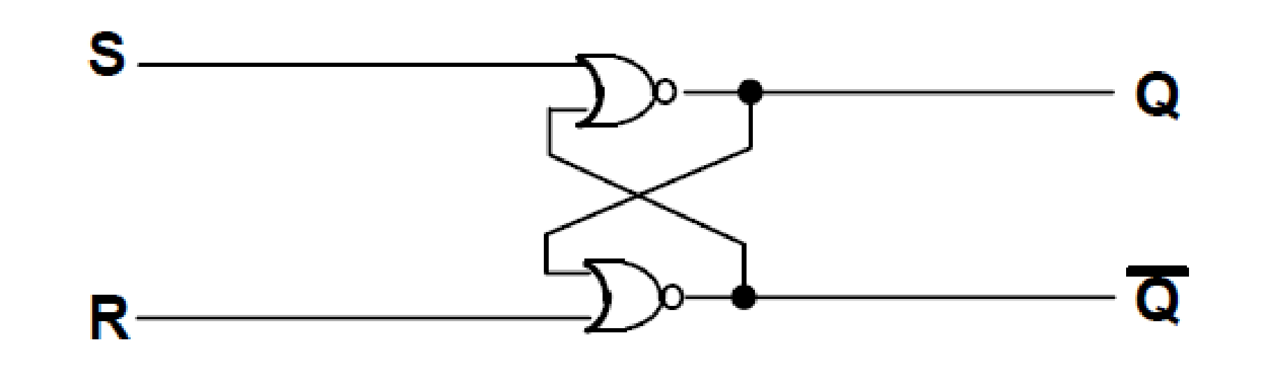

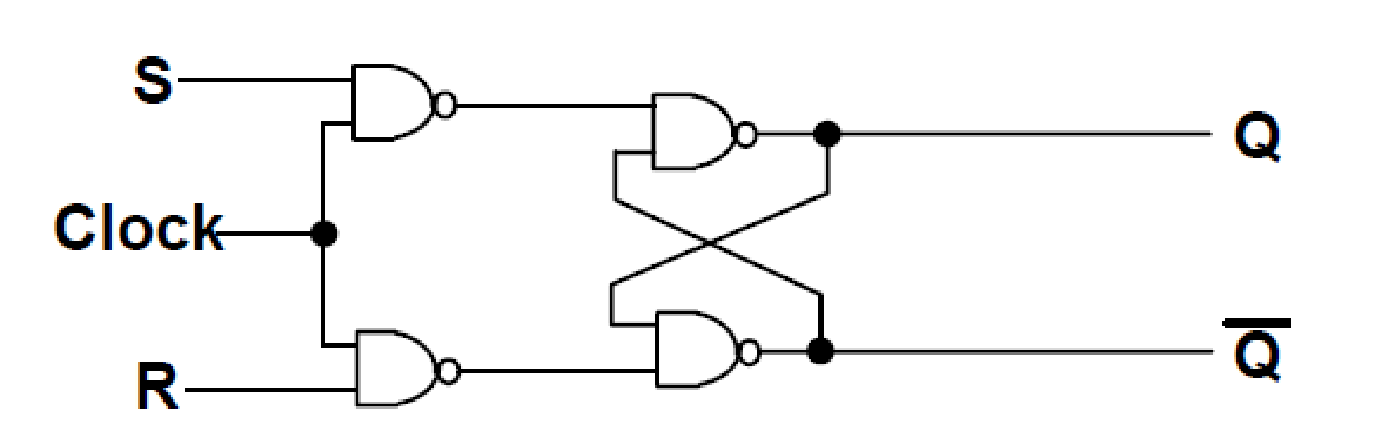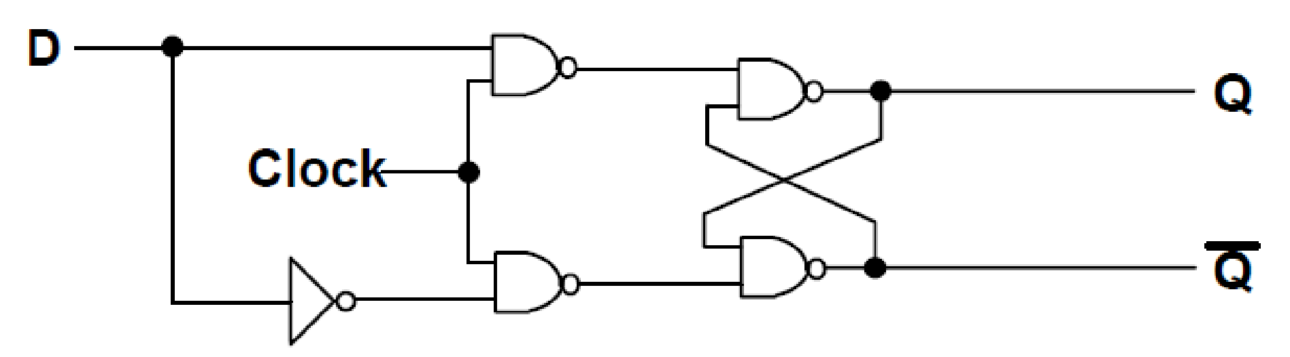

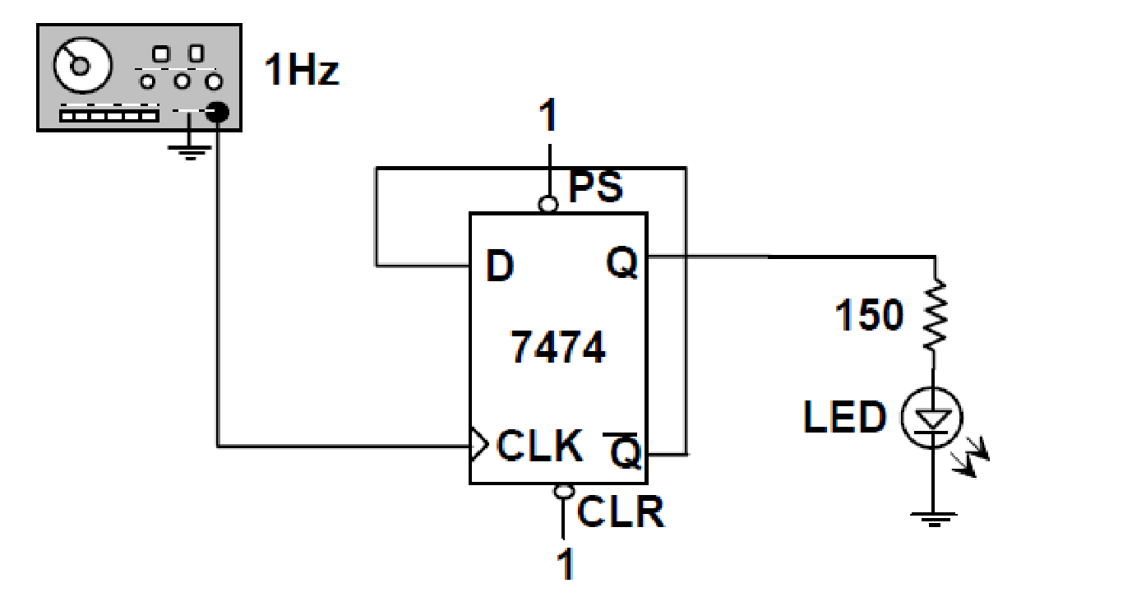

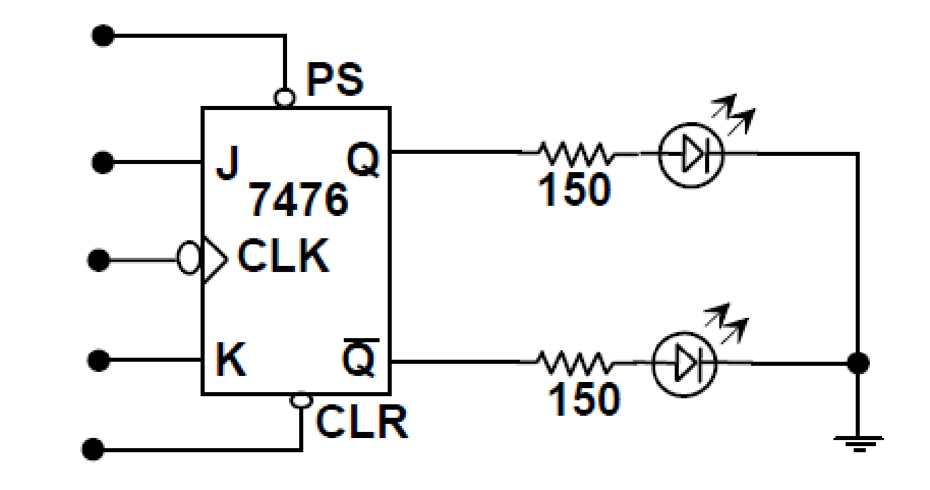

**Experiment # 6:**

**Design and Implement of Astable multivibrator using 555 timer**

**Objectives**

* To learn to use the oscilloscope for troubleshooting digital circuits
* To learn to use the function generator as a source of digital signals

**Equipment:**

* Oscilloscope
* Function generator with analog and digital outputs
* Breadboard and wires
* 555 Timer
* Resistors : 150Ω(1), 1KΩ(1), 4.7KΩ(1), 470KΩ(1)
* Capacitor

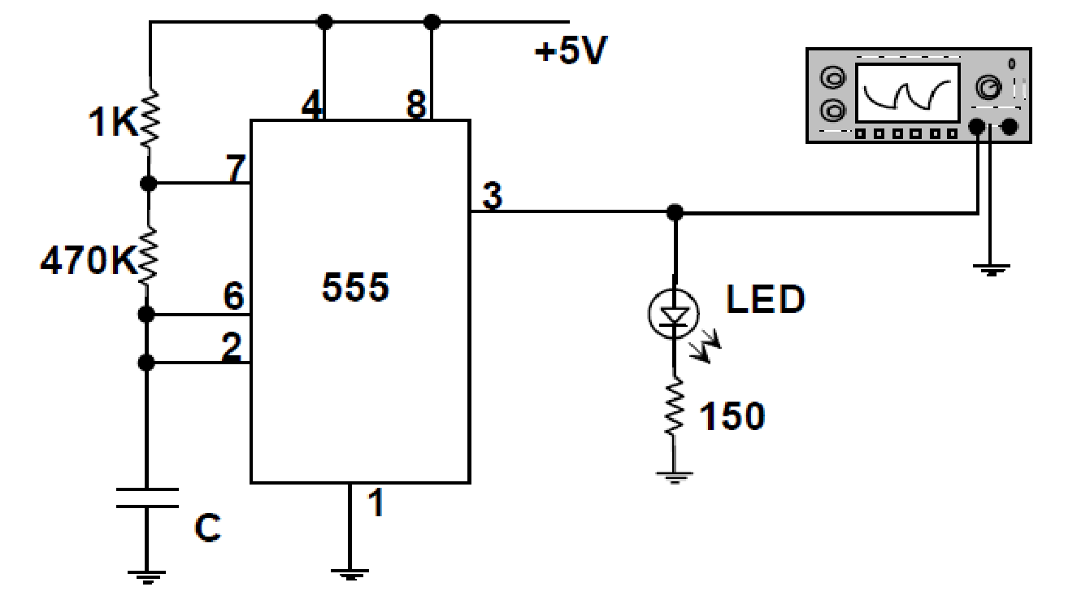

**Experiment # 7:**

**Design and Implement of Monostable multivibrator using 555 timer**

**Objectives**

* To learn to use the oscilloscope for troubleshooting digital circuits
* To learn to use the function generator as a source of digital signals

**Equipment:**

* Oscilloscope
* Function generator with analog and digital outputs
* Breadboard and wires
* 555 Timer
* Resistors : 150Ω(1), 1KΩ(1), 4.7KΩ(1), 470KΩ(1)
* Capacitor